**Project Design Phase-I**

**Solution Architecture**

|  |  |
| --- | --- |
| Date | 19 September 2022 |
| Team ID | PNT2022TMID43270 |
| Project Name | Signs with smart connectivity for better road safety |
| Maximum Marks | 4 Marks |

**Solution Architecture:**

**Introduction**

In its Global Status Report on Road Safety – 2015, the World Health Organization (WHO) noted that the worldwide total number of road traffic deaths has plateaued at 1.25 million per year, with tens of million either injured or disabled [1]. Different initiatives, such as the United Nations’ initiative for the 2011-2020 Decade of Action for Road Safety, have led to improvements in road safety policies and enforcements. However, the WHO notes that the progress has been slow and has maintained the call for urgent action to reduce these figures

Added to the losses in human lives and wellbeing, considerable monetary losses are incurred in medical expenses, infrastructure repair, and production downtime. While the worldwide figures have plateaued, the Global Status Report does indicate higher road fatalities and injuries in low-income countries. Such disparity, as noted in [3], signals a barring-limitation in low-income countries to improve road-safety by adopting solutions implemented in high-income countries.

**Example - Solution Architecture Diagram:**

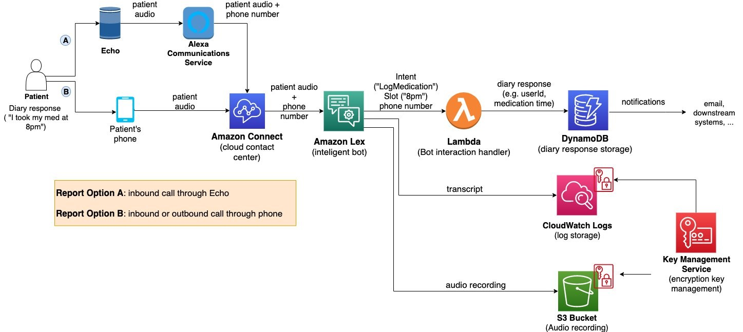

Figure 1: Architecture and data flow of the voice patient diary sample application

##### **The Safe System Approach**

The Safe System (SS) approach to transport networks originated with the “Safe Road Transport System” model developed by the Swedish Transport Agency. In its essence, the approach migrates from the view that accidents are largely and automatically the driver’s fault to a view that identifies and evaluates the true causes for accidents. Through the categorization of safety into the safety of three elements (vehicle, road, and road user), SS minimizes fatalities and injuries by controlling speeds and facilitating prompt emergency response. The model has been widely adopted since its introduction and is currently motivated by the WHO as a basis for road safety planning, policy-making, and enforcement.

An illustration of the model is provided in Figure [1](https://www.hindawi.com/journals/wcmc/2018/8214989/fig1/). A central emphasis is given to speed in the SS approach as it is the strongest and most fundamental variable in the outcome of fatality. The fragility of the human body makes it unlikely to survive an uncushioned impact at a speed of more than 30 km/h, with lower speeds resulting in either death or serious injury [3, 4]. The objective of the SS approach is that the three model elements should be designed and monitored to proactively prevent deadly speeds from happening and allow for a reduced emergency response time in the event of an accident.

#### An IoT Architecture for Assessing the Safety of a Dynamic Road Transport System

In reviewing the related works in the previous section, we showcased how various advances are enabling the assessment of safety of vehicles, roads, and drivers. The objective of this section is to introduce a novel and adaptive IoT architecture that enables the assessment of safety in a city’s road network. We elaborate on the assessment elements and how they can be used to synthesize a single, meaningful indicator for safety. We also describe the architecture components and their interrelationships, including a robust computational core for safety assessment.

##### 3.1. Assessment Elements

The way the SS approach comprises the three elements of safe vehicle, safe road, and safe driver facilitates a hierarchical safety assessment approach whereby the safety of the individual elements can provide a collective indicator of safety for the road network, as illustrated in Figure [3](https://www.hindawi.com/journals/wcmc/2018/8214989/fig3/). In turn, this indicator can be concatenated from the assessment of individual road segments, to routes, to the road network.

#### Safety-Based Route Planning

Route planning has become widely used in both personal and commercial use, resulting in an increasing dependence on its reliability. Various applications employ efficient algorithms for route planning [43]. Trip time and cost, e.g., for tolls, have been the typical metrics for route planning applications, but other metrics, however, have been utilized, e.g., for fuel emission/consumption or energy requirements of electric vehicles.

Using the dynamic safety assessment proposed above, it is now possible to route vehicles across cities based on a safety. In this manner, drivers can be directed through routes that minimizes their overall risk in traversing the road network. Meanwhile, enforcement can distribute vehicles across different paths to distribute risk of the network and avoid having critically unsafe links or routes within the network. It is furthermore possible to target auxiliary mechanisms for safety-control across the network by controlling and redirecting traffic based on user driving behavior or in-response to incidental changes in the road network.

